**Indira College of Engineering and Management (MCA) Parandwadi, Pune**

**SYMCA Semester III Mini Project**

2021-22

# “Food Order System”

****

SUBMITTED BY -

**Nainesh Gopalrao Iche – 23029**

Under the Guidance of -

**Dr. Darshana Desai**

**CERTIFICATE**

**To whom so ever it may concern**

**This is to certify that Mr NAINESH GOPALRAO ICHE Roll No 23029 from SYMCA has successfully carried out the project titled Food Order System Using JAVA (Android Studio) , Firebase technology for the fulfilment of Semester III.**

**Project Guide Name**

**Sign**

**Table of Contents**

**Chapter 1: Introduction**

1.1 Existing System and Need for System

1.3 Scope of Work

1.4 Operating Environment – Hardware and Software

1.5 Detail Description of Technology Used

**Chapter 2: Proposed System**

2.1 Proposed System

2.2 Objectives of System

2.3 User Requirements

**Chapter 3: Analysis & Design**

3.1 Module Hierarchy Diagram

3.2 Use Case Diagram

3.3 Class Diagram

3.4 ER diagram

3.4 Activity Diagram

3.5 Sequence Diagram

3.6 Web Site Map Diagram (in case of Web Site)

3.7 User Interface Design (Screens, Reports, etc.)

3.8 Database Table Structure

**Chapter 1: Introduction**

## Existing System and Need of the System:

In the present scenario, people have to physically visit the hotels or restaurants for eating food and have to make payments through cash mode most of the time due to unawareness of advanced technologies at certain places. In this method time as well as physical work is required, among which time is something that no one has in ample amount.

The traditional food ordering procedure is not efficient enough for hotels and restaurants, as they have to deal with the crowd, in their restaurant. The old methods can be classified into categories which are paper grounded and verbal grounded. For paper-based work, the waiter comes and pens down foods that customers order and pass the food list containing paper to the chefs or cooks in the kitchen for further process.

Also, from the owner’s point of view maintaining data records and the accounts in the physical file are quite difficult and tedious work to do. And also, it is full of risk as anyone can access it and modify the data.

## Future Scope of the System:

This order food online system project aimed at developing an online food ordering system that can be used in small places, and medium cities firstly and then on a large scale. It is developed to help restaurants to simplify their daily operational and managerial task as well as improve the dining experience of customers. And also helps restaurants develop healthy customer relationships by providing good services. The system enables staff to let update and make changes to their food and beverage list information based on the orders placed and the orders completed.

**Operating Environment**

**Software Requirements:**

* Windows 7, Windows 10.
* Android Studio, Visual Studio Code.
* Linux Kernel.
* Firebase DB

**Hardware Requirements:**

**PC Laptop Configuration**

* Processor – i3 or any higher version
* Hard Disk – 10 GB or more
* RAM – 8GB RAM or more

**Android ( Linux kernel ) Configuration**

* Android Version – Above Android 6.0 (Marshmallow)
* Storage – 30 MB or more
* RAM – 2GB RAM or more

**Technologies Used:**

**Front-end Design [ Android Studio (JAVA) ].**

In recent times, Android became the world's most popular operating system for various reasons. As an Android programmer, I want to share what the Android Studio is? Android Studio is an IDE for Google Android Development launched on 16th May 2013, during Google's I/O 2013 event. Android Studio contains all the Android tools to design, test, debug, and profile your application. The Android Studio uses [Gradle](https://gradle.org/) to manage your project, a Build Automation Tool. You write Android apps in the Java programming language using an IDE called Android Studio. Based on JetBrains' IntelliJ IDEA software, Android Studio is an IDE designed specifically for Android development.

**DataBase [ Firebase ]**

Firebase is a Cloud-hosted, NoSQL database that uses a document-model. It can be horizontally scaled while letting you store and synchronize data in real-time among users. This is great for applications that are used across multiple devices such as mobile applications. In recent times, Android became the world's most popular operating system for various reasons. As an Android programmer, I want to share what the Android Studio is? Android Studio is an IDE for Google Android Development launched on 16th May 2013, during Google's I/O 2013 event. Android Studio contains all the Android tools to design, test, debug, and profile your application. The Android Studio uses [Gradle](https://gradle.org/) to manage your project, a Build Automation Tool.

**Chapter 2: Proposed System**

**Proposed of the System:**

This system is a bunch of benefits from various points of view. This online application enables the end-users to register to the system online, select the food items of their choice from the menu list, and order food online. Also, the payment can be made through online mode or at the time of home delivery depending upon the customer’s choice and convenience.

The selection made by the customers will be available to the hotel reception or to the person handling the work assignment. Now this same person will assign the orders to the specialist chef to be completed within a fixed duration of time. As soon as the chef prepares the food, the later person forwards the parcels to the delivery persons assigned with the location and customer identity of the customer along with the bill status.

One of the various benefits of this is system is that if there is a rush or a huge crowd present in the restaurant then in that case sometimes unavailability of tables cut downs the restaurant’s customer.

Also, there will be chances that the waiters are unavailable as they are busy handling others, so the customer can directly order the food to the chef online by using this application, by checking the seat availability in the restaurant. This system allows the staff to serve customers within less time as compared to the manual system.

**Objectives of the System:**

The main objective of the Online Food Ordering System is to manage the details of Item Category Food Delivery Address, Order Shopping Cart. It manages all the information about Item Category, Customer, Shopping Cart, Item Category. The project is totally built at administrative end and thus only the administrator is guaranteed the access. The purpose of the project is to build an application program to reduce the manual work for managing the item Category Food Customer, Delivery Address. It tracks all the details about the Delivery Address Order Shopping Cart. We all know that with COVID-19 becoming increasingly widespread, the lives of people around the world have changed. Most countries have announced shutdowns, and life, as we know it, has changed completely. Almost everything is closed except for essential services. Whether it is grocery delivery or food delivery services, every essential business is growing. Many startup businesses have started to invest in 10-minute delivery apps, such as Dija and Weezy apps. The aim of these objectives of food delivery services are to deliver quality food in less time. These apps promise you to deliver your groceries within 10 minutes. The target market also used to be busy people who needed a restaurant delivery service because they didn’t have time. Now, the target market is everyone. Most people now require home deliveries. With people practicing social distancing, self-quarantine, and staying indoors to stop the spread of the virus, food-delivery startups are in demand more than ever. They cater to more orders than ever. Food delivery companies can actually help people stay indoors and fight this pandemic.

**User Requirements**

* Create an account.
* Manage their account.
* Log in to the system.
* Navigate the restaurant’s menu.
* Select an item from the menu.
* Add an item to their current order.
* Review their current order.
* Remove an item/remove all items from their current order.
* Provide payment details.
* Place an order.
* Receive confirmation in the form of an order number.
* View order placed.

**Analysis & Design**

**Module Hierarchy Diagram:**

**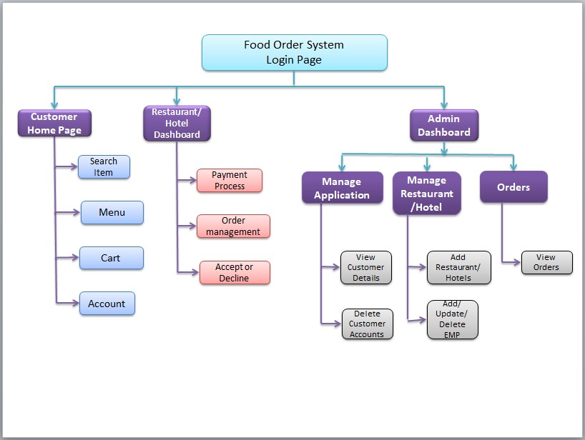**

**Use Case Diagram:**

**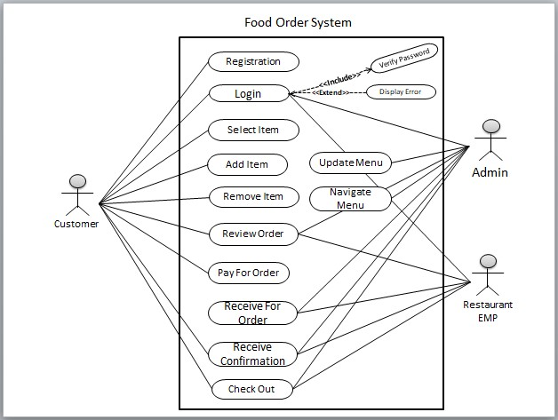**

**Class Diagram:**

# D:\Android-Studio\Projects\Food_Corner\ScreenShots\Class Diagram.jpg

**E-R Diagram:**

**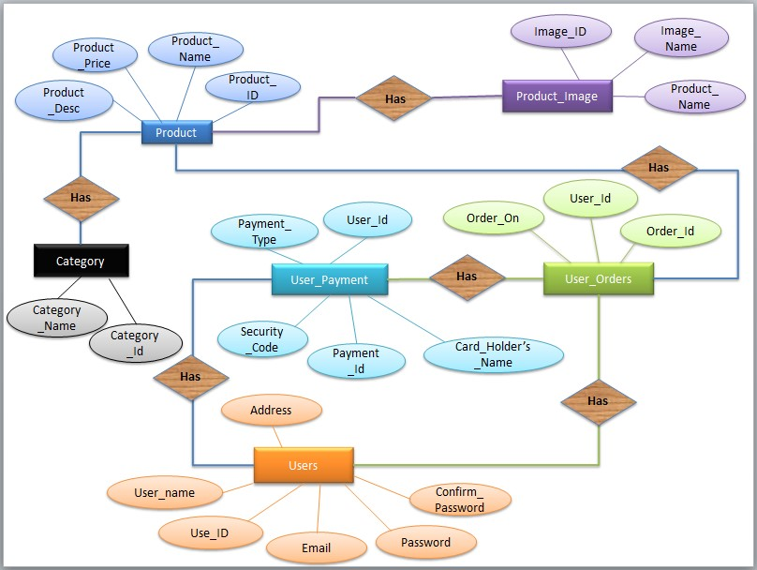**

**Activity Diagram (Admin):**

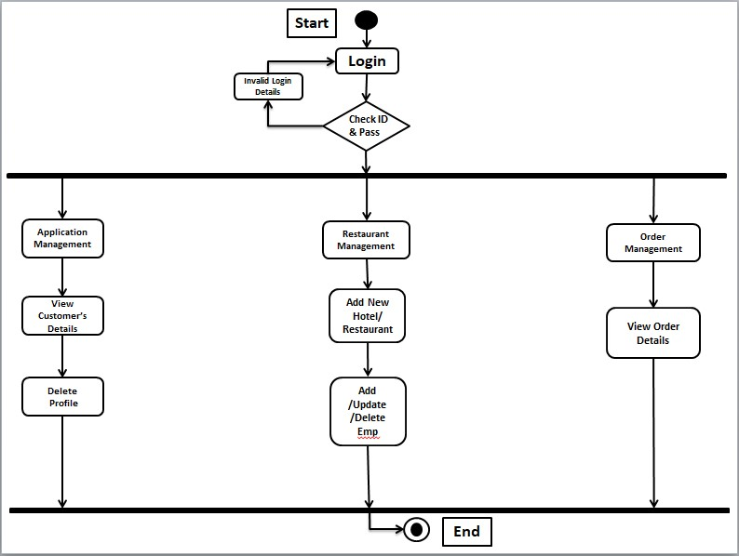

**Activity Diagram (Customer):**

**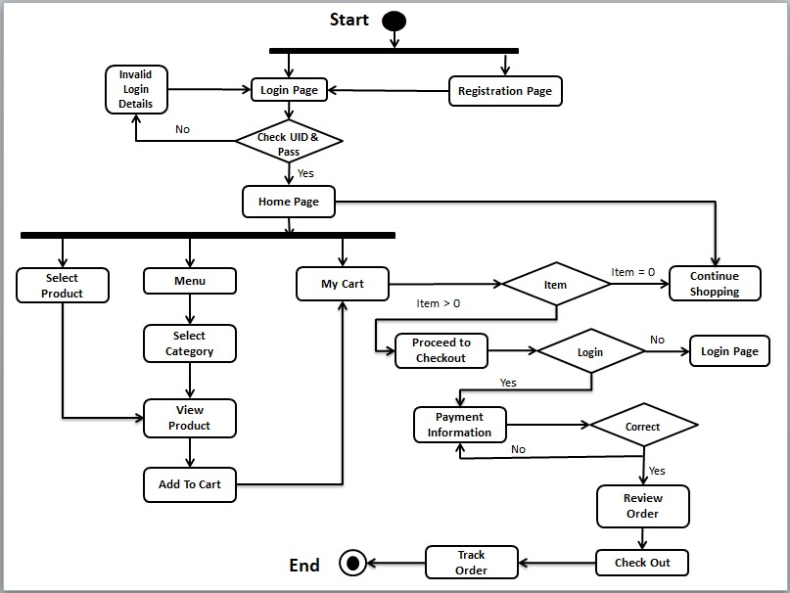**

**User Interface Design**

